Note: how to run the code:
From the Initial Models folder, run “python main.py” to run all four ML models.
To specify which ones to run, include list of models as command line arguments. For example, to just run logistic regression and svm, run “python main.py logistic svm”

Joseph Shin and William Stanton
March Madness Project

Initial Models Report
For this part of the project, we decided to use relatively simple machine learning models to try to predict two different columns in our dataset – School Type (private or public) and NCAA Tournament Seed. As our baseline for both questions, we decided to always predict the testing data to be the most frequent value in the training data. We then compared those results with the results of four common machine learning algorithms – Logistic Regression, Random Forest, Gradient Boosting, and Support Vector Machines (SVMs). Our results are below.

Question 1: Predicting School Type (Private vs Public)
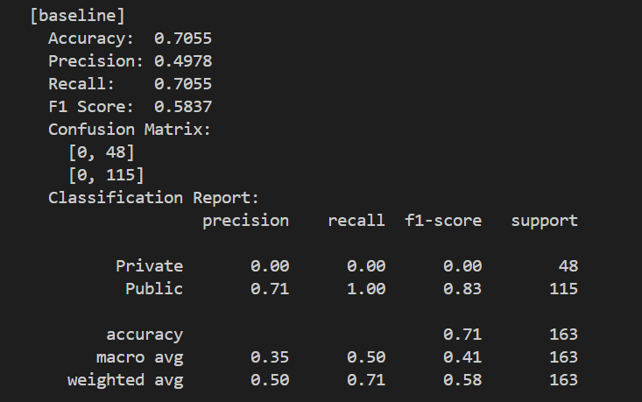
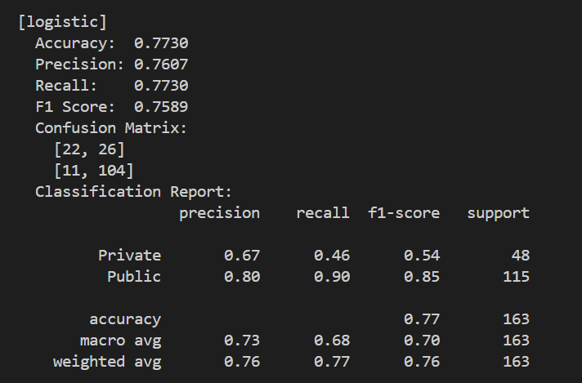
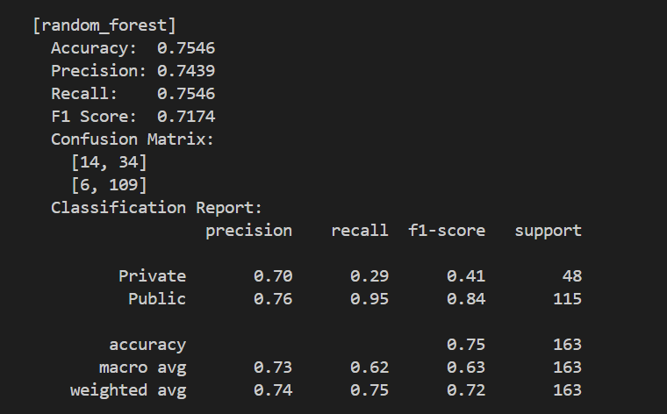
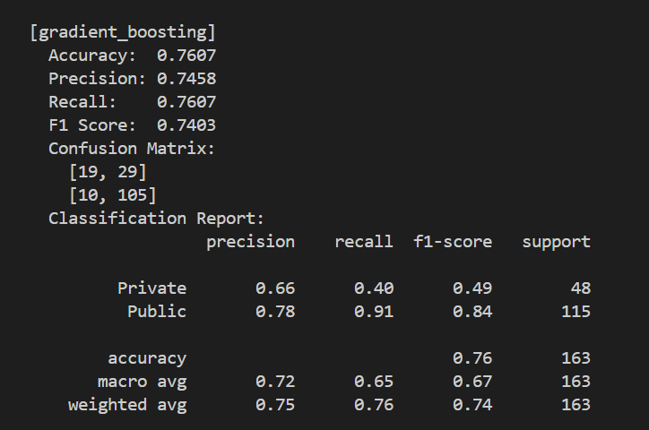
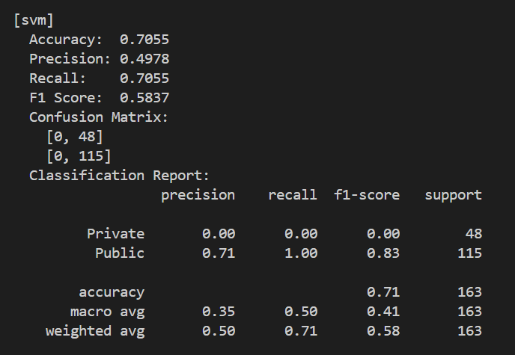
As seen above, all of the ML models performed slightly better than the baseline with the exception of SVM, which classified the data in the same way as the baseline. The other three models had slightly higher accuracies (77%, 75%, 76%) than the baseline (71%) but are not drastically better. The parameters and hyperparameters likely need to be tweaked to obtain a model that can confidently classify private vs public schools based on metrics from their respective basketball teams.

Question 2: Predicting NCAA Tournament Seed
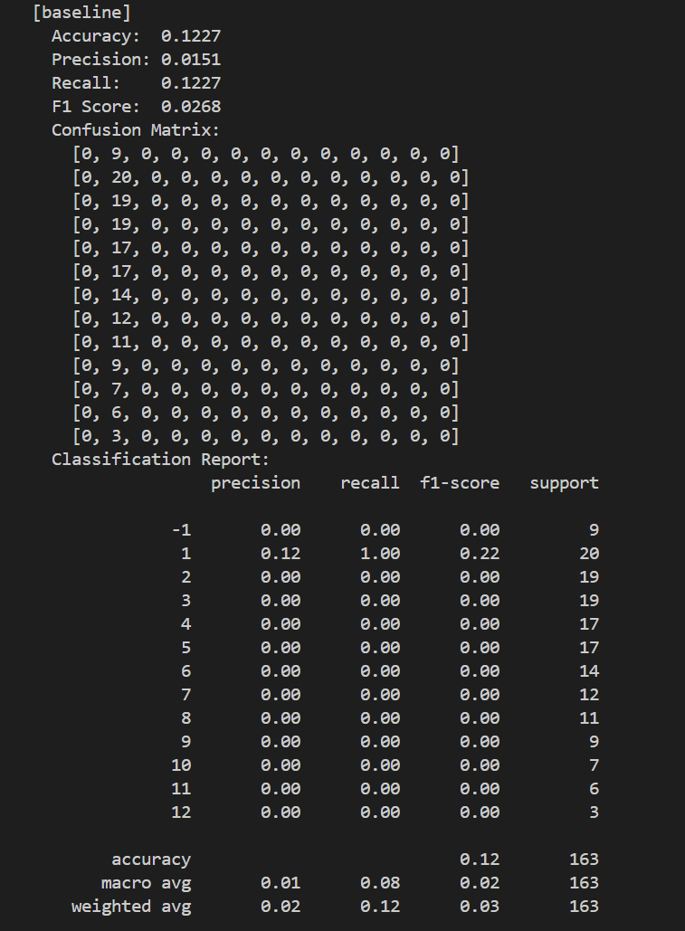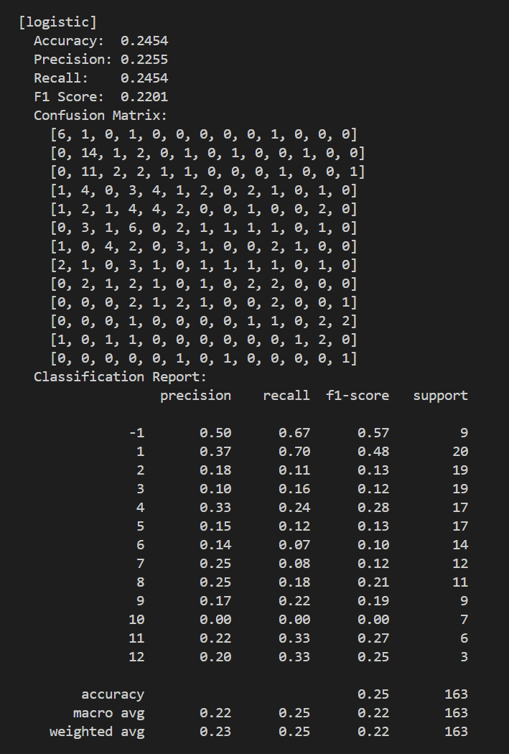

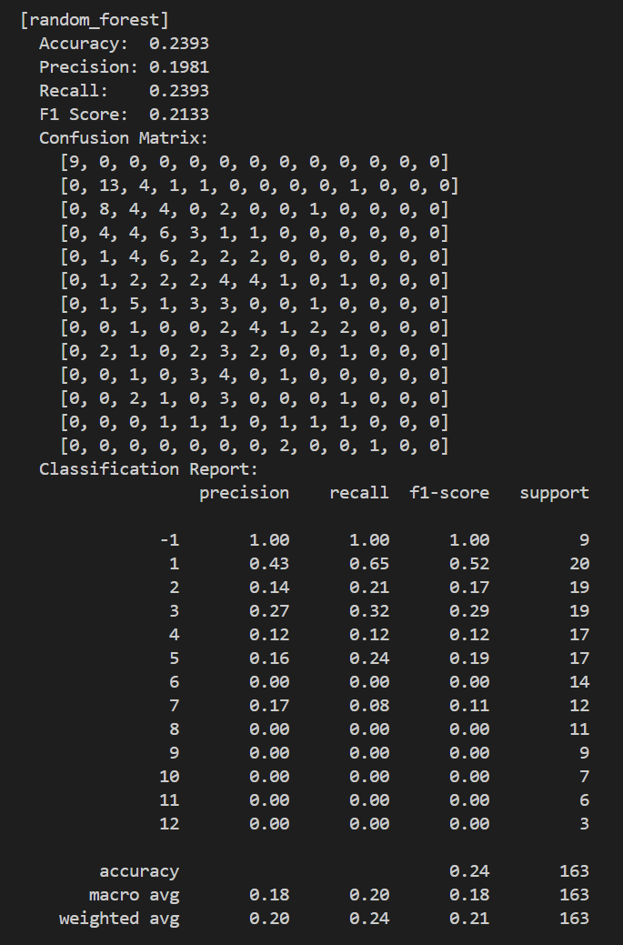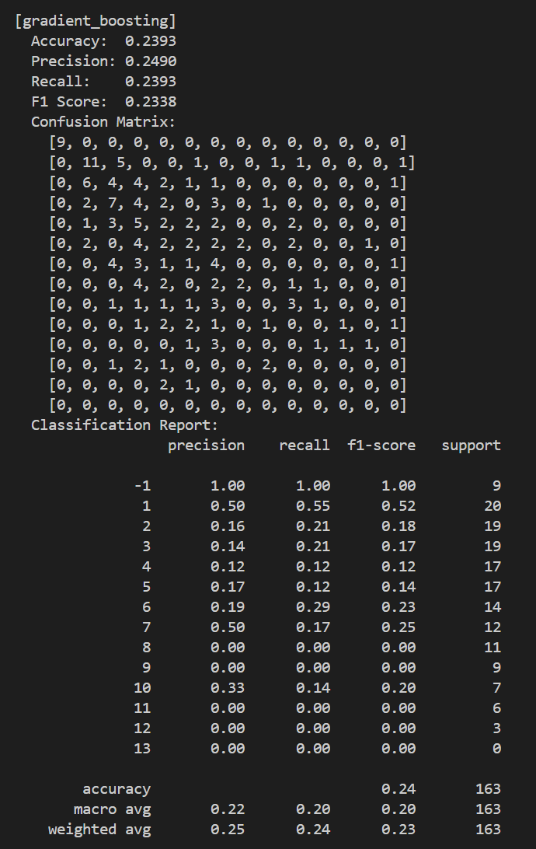
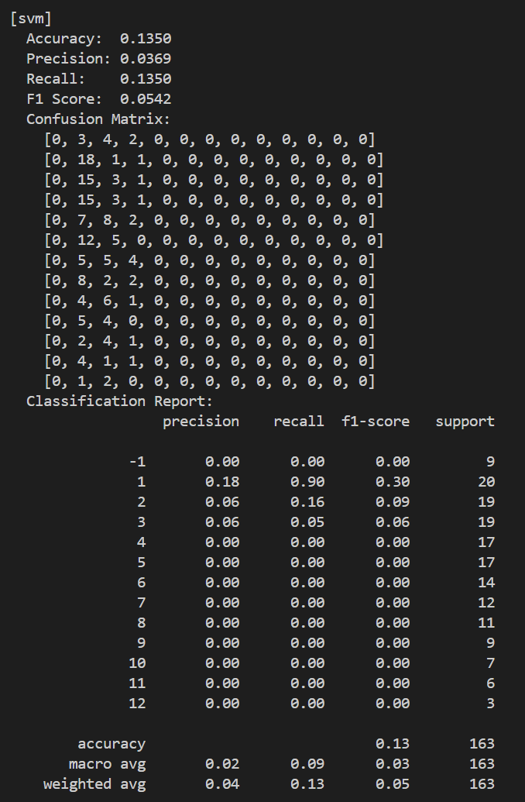

As seen above, once again the logistic regression, random forest, and gradient boosting models outperform the baseline (predicting most common class for each) and the SVM models. This time, the SVM model had slightly better accuracy than the baseline (13.5% vs 12.3%) but not by much. The other three models had accuracies of 24.5%, 23.9%, and 23.9% respectively. This tells us that seeding in the tournament is hard to predict with the columns that we had, which is not surprising given that much more goes in to seeding teams that their basketball statistics such as offensive efficiency and block rate, which is what most of our data is. These models will need refinement and possibly additional data in order to confidently predict which seed a given team will be.

